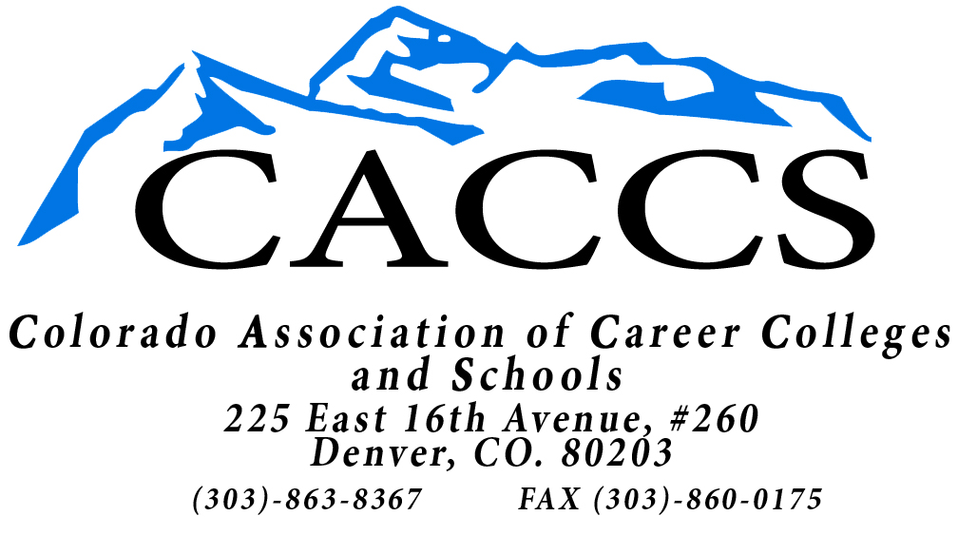
8074 Grove Street
Westminster, CO 80031
303-863-8367

DATE: Jan. 4, 2013

SUBJECT: CACCS 2013 Scholarship Program

Please find enclosed the Colorado Association of Career Colleges and Schools 2013 scholarship packet. These scholarships may be used at any of the following schools:

American Institute of Technology | Anthem College
Art Institute of Colorado | At-Home Professions
Colorado School of Healing Arts | Colorado School of Trades
Colorado Technical University | Concorde Career College
Denver School of Massage | Denver School of Nursing
DeVry University | Everest College
Heritage College | Highlands Ranch Public Safety Training
ITT Technical Institute | Institute of Business & Medical Careers
Intellitec College | Intellitec Medical Institute
International Salon & Spa Academy | Lincoln College of Technology
National American University | Pima Medical Institute
Platt College | Redstone College
Starkey Int’l Institute Household Mgmt | Westwood College of Technology

The amount of the scholarship is $1,000. Please take time to post photocopies of this document in the appropriate locations at your facility. PLEASE LIMIT THE NUMBER OF APPLICATIONS TO TWO (2) FROM YOUR SCHOOL.

Please be aware that this program cannot be used by the school as a recruiting tool or an enticement to enroll.

If you have any questions concerning the scholarship program, please do not hesitate to call Sally Kemp at 303-863-8367

sk

Enclosure

8074 Grove Street
Westminster, CO 80031
303-863-8367

2013 SCHOLARSHIP

PURPOSE
The Colorado Association of Career Colleges and Schools (CACCS) Scholarship was created to encourage and assist qualified students to continue their education. It was also designed to motivate students to attend colleges within the State of Colorado and to recognize the importance of the private technical trade schools. The scholarship may be used at any post-secondary private technical college that is a member of the Colorado Association of Career Colleges and Schools (list enclosed).

ELIGIBILITY
Students are eligible to apply for the Colorado Association of Career Colleges and Schools Scholarship if they are:
1. High school seniors, high school graduate, or have a GED.
2. Currently enrolled or planning to enroll in a full-time course of study at any CACCS member institution in the state of Colorado. Students must have been accepted by the institution during the year for which the scholarship is awarded.
3. Maintaining a minimum of a “B” average while in high school or while enrolled in a CACCS member
school.
4. A resident of the State of Colorado.

THE AWARD
The Colorado Association of Career Colleges and Schools Scholarship will award two (2) scholarships for each year. The scholarships will be $1,000 each. One recipient will be a high school senior, and one will be post high school, residing within the State of Colorado. This is designed to gain more exposure of the CACCS. Awards may be used for tuition, fees, books, or supplies at the college selected. The scholarship must be used during the calendar year for which the scholarship is awarded. If the recipient for some reason fails to enter a school within the calendar year for which the scholarship is awarded, that recipient will forfeit the scholarship. The Committee, at that time, reserves the right to award the scholarship to another recipient.

APPLICATION PROCEDURE
Students who meet the eligibility requirements of the guidelines of the Colorado Association of Career Colleges and Schools Scholarship are invited and urged to complete the attached application. Mail the completed application to: Colorado Association of Career Colleges and Schools Scholarship Foundation, 8074 Grove Street, Westminster, CO 80031, Attention: Sally Kemp. All applications will be forwarded to the Action Committee of the Colorado Association of Career Colleges and Schools for selection of the award. Only those applications received in the CACCS office by February 1, 2013 will be considered. Applicants should take special care to answer each question on the application and to sign the application. For high school students, please include an official high school transcript or a “student copy” of your transcript with the application.

Applicants who are attending CACCS member schools must include a copy of their most current college transcript. Please include a personal statement not to exceed one typewritten page about yourself regarding your educational and career goals, and how you plan to make a difference in the community. Also include two letters of recommendation from outside your immediate family, preferably from employers, teachers and other professionals.

NOTE: Any information or criteria not included with any submission will automatically disqualify that submission from the selection procedure.

SELECTION PROCEDURE
The Colorado Association of Career Colleges and Schools Scholarship is administered entirely by a panel of the CACCS Action Committee. The decision of the Committee is final.

ANNOUNCEMENT AND DISTRIBUTION OF AWARD
Scholarship recipients will be notified before the end of April. All checks will be made payable jointly to the student and the school where he or she is enrolled and must be endorsed by both. Awards may be used to pay tuition, fees, books or supplies needed for attendance at that institution.

OBLIGATION OF RECIPIENTS
Scholarship recipients have no obligation to the Colorado Association of Career Colleges and Schools other than a commitment to remain in their educational program for a minimum of one year. However, they must provide upon request, proof of their continuing eligibility for the program that was entered. Any pro-rated portion of a scholarship to be refunded due to a recipient not completing the course/program paid for by the scholarship will be refunded to the scholarship account at CACCS as applicable. Colorado Association of Career Colleges and Schools reserves the right to use the name and/or photograph of the recipient in the future to advance the Colorado Association of Career Colleges and Schools in the State of Colorado.

COLORADO ASSOCIATION OF CAREER COLLEGES AND SCHOOLS

2013 EDUCATIONAL TUITION SCHOLARSHIP APPLICATION

NAME:______________________________
ADDRESS:_______________________________ PHONE:____________________

CITY, STATE/ZIP:

EDUCATION

High School ____________________________________ Graduation Date:

Academic Awards:

Extra-Curricular Activities

Community/Volunteer Activities:

POST-SECONDARY SCHOOL WHERE SCHOLARSHIP WILL BE USED

NAME OF COLLEGE:__________________________________________________________

ADDRESS OF COLLEGE:______________________________________________________ _

PHONE:____________________________________EXPECTED GRAD DATE:___________ _

PROGRAM OF STUDY:___________________________________________________________ __

PERSONAL STATEMENT:
On a separate sheet of paper please provide a personal statement regarding your educational and career goals and how you plan to make a difference in the community. (Please limit personal statement to 1 typewritten page).

Please include two (2) letters of recommendation from outside your immediate family. High school students must include their most recent high school transcript and applicants attending CACCS member schools must include their current college transcript.

I understand that if for some reason I fail to enter a school, I will forfeit my rights to this scholarship, if chosen. The Colorado Association of Career Colleges and Schools reserves the right to use my name and/or photograph, if chosen, to promote this scholarship or the CACCS.

APPLICANT’S SIGNATURE:__________________________________DATE:_________ _

Return this application by February 1, 2013

Colorado Association of Career Colleges and Schools
8074 Grove Street
Westminster, CO 80031
E-mail to sallyk@tde.com or Fax to 303-650-0682

LIST OF SCHOOLS THAT PARTICIPATED IN THE 2012 PROGRAM

Anthem College
Art Institute of Colorado
Colorado School of Healing Arts
Denver School of Nursing
DeVry University
Heritage College
Institute of Business and Medical Careers
Intellitec College
International Salon & Spa Academy
ITT Technical Institute
Lincoln College of Technology
Pima Medical College
Platt College
Redstone College
Westwood College

WINNERS OF THE 2012 SCHOLARSHIPS

Enrolled in CACCS Member Institute
Christian Schmidt ITT Technical Institute

Enrolled in High School
Candace Cook International Salon & Spa Academy
Lizbet Gonzalez Intellitec College - Grand Junction

